PASSENGER CONTROL IN SMART CITIES USING DEEP LEARNING

Delna T D, Dhanya P Pauly, Dona Johnson, Jesta Jose

Department of Computer Science and Engineering

Sahrdaya College of Engineering and Technology Kodakara
Thrissur

APJ Abdul Kalam Technological University

delnadaisy@gmail.com

dhanyapauly@gmail.com

mjmdona@gmail.com
jestajose398@gmail.com

Abstract— In the current context of smart city, due to increasing growth of population and vehicles in smart and metropolitan cities people face a lot of accidents at the major traffic points of the business towns. In this method we consider the auto taxies as well as the public transport. We know that due to the overload in the vehicles the accidents are increasing day by day so using this method the number of accidents can be avoided or reduced. This system is introducing a deep learning approach to find the overload in vehicles. We are considering the luggage that is taken along with the passenger and an average weight is given for the load. Then it is combined with the number of passenger and system will predict whether the vehicle is overload or not. Mainly because of using deep learning concepts we can increase the speed of the process and the efficiency. The system will analyse the number of passengers using real time videos using camera and system detect and compare with the overloading conditions to avoid accidents.

I. INTRODUCTION

This section gives an overview about the objective of the project. System predicts the number of passengers in the vehicle and the load. It detects the number of passenger in the vehicle using deep learning. Number of passengers beyond a limit is not encouraged to travel in the vehicle. The passenger control in smart cities is planning of avoiding overload in taxies. Proposed system provides the detection of passenger overload in taxies. Overload can be detected by using passenger detection method. This is one of the best methods to detect overload in auto taxies. In this we consider the auto taxies as well as the public transport. Setting the limit for passengers according to capacity of the vehicle. Number of passengers will be counted and also it will detect the back bag, luggage and school bag .A deep learning system will be provided in the corresponding vehicle with camera. The system is introducing and a deep learning approach to find the overload in vehicle. Deep learning is a subset of machine learning where artificial neural networks, algorithms inspired by the human brain, learn from large amounts of data. Deep learning allows machines to solve complex problems even when using a data set that is very diverse, unstructured and inter-connected. It will give a warning if there is overload in

taxies. Through this number of accidents due to overload can be avoided. Camera is used to acquire the real time video inside the vehicle and system detects and analyzes the overload using deep learning mechanism. Face detecting whether the face is of the human and it will divide the passengers as single blocks and then count the number of blocks. The number of blocks is equivalent to the count of passengers and is not effective for the vehicle’s overload detection. So we find the luggage that is taken along with the passenger and an average weight for the load is given. This is then paired with the number of passengers, and the system can determine whether or not the car is overloaded.

II.DRAWBACKS OF EXISTING SYSTEM

Passenger overload in public transport lead to many accidents. The existing system detects the load in the vehicle but it is not predicting whether it is human overload or the load in the vehicle. The vehicle suspension system can transmit forces and torques acting between the wheel and the frame, and cushion the impact force transmitted from the uneven road surface to the frame or the body to absorb the energy generated by the impact.Changes in vehicle load can cause deformation of the elastic element, the vehicle body will have a displacement in the vertical direction. Therefore, under static conditions, different vehicle loads correspond to a certain distance between the vehicle body characteristic points and the road surface. When there is a vehicle vibration excitation input, the vehicle suspension generates a vibration response, and the distance from the characteristic point on the vehicle body to the ground constantly changes. Load value recognition model based on characteristic distance. The bearing characteristics of the front suspension and the rear suspension can be calculated. The characteristic distance of the front and rear suspensions can be obtained through the visual roadbed and the static deflection value is obtained.
Therefore, the major drawbacks of the existing system are

- Only concerns about the load of the vehicle.
- Not predicting the passenger count and overall weight.
- Cannot be used in public transport for passenger safety.
- Accuracy in weight is less.
- Lack of knowledge about the number of passengers

III.METHOD

The system we are introducing makes use of various domains namely deep learning. The whole system can be broadly categorized as two parts i.e., the detection part and the classification part. Proposed system provide the detection of passenger overload in taxies. Overload can be detected by using passenger detection method. In this method we consider the auto taxies as well as the public transport .Setting the limit for passengers according to capacity of the vehicle .Number of passengers will be counted and also it will detect the back bag, luggage and school bag .A deep learning system will be provided in the corresponding vehicle with camera. The system is introducing and a deep learning approach to find the overload in vehicle .It will give a warning if there is overload in taxies .Through this number of accidents can be avoided. Acquire the real time video using camera and system detect and analyze the overload using deep learning mechanism using camera. One camera at front and other at top .Face detecting whether the face is of the human and it will divide the passengers as single blocks and then count the number of blocks. The number of blocks are equal to number of passengers it is no efficient for overload detection of the vehicle. So we are considering the luggage that is taken along with the passenger and an average weight is given for the load. Then it is combined with the number of passenger and system will predict whether the vehicle is overload or not.
Count the number of passengers according to the real time video through camera and compare it with data given in the database .In analysis phase the passenger count is compared with limit in the system. Changes in vehicle load can cause deformation of the elastic element, the vehicle body will have a displacement in the vertical direction. Therefore, under static conditions, different vehicle loads correspond to a certain distance between the vehicle body characteristic points and the road surface. When there is a vehicle vibration excitation input, the vehicle suspension generates a vibration response, and the distance from the characteristic point on the vehicle body to the ground constantly changes weight. When the number of people travelling on holidays is more, it is easy to cause overload phenomenon. YOLOv3 system predicts many detection boxes after classifications of the classifier, and many of them intersect with other boxes over a large area. Every candidate box has a confidence score, which reflect how confident the model is that the box contains an object. These studies takes advantages of the computer vision and do all the jobs of door switch detection, floor detection and passenger detection by only using the camera sensor, and achieves the goal of passenger flow statistics in real detection. In this system, passenger flows are counted by camera and the loads is also calculated and predict whether it overload or not passengers using YOLOv3 method.

The traditional identification method of vehicle overload is setting up detection points on highways. In this approach, it is difficult to accurately identify whether it is overloaded. Fixed platform detection station can accurately identify the weight of vehicles, but the installation is complex, difficult to large-scale promotion. With the continuous development of the transportation industry, the problem of vehicle overload becomes more and more serious. Vehicle overload seriously damages road facilities and causes road traffic accidents, which poses a threat to people's life and security. The method of vehicle balance is based on capacitive sensor. When the capacitive sensor detects the vehicle's load, the force of the vehicle on the ground changes the distance between the two plates of the capacitive sensor, resulting in the change of capacitance capacity. The vehicle balance is bulky, expensive, and destructive to the road and low efficiency in vehicle load. The detection of passenger overload in taxies based on deep learning it is unsupervised learning in that unstructured or un labelled data is predicted using unsupervised learning. It is a subset of machine learning where artificial neural networks, algorithms inspired by the human brain, learn from large amounts of data. Deep learning allows machines to solve complex problems even when using a data set that is very diverse, unstructured and inter-connected.

Fig 3.1 shows the architectural diagram of the proposed method. In this initially a of predicting passenger over load in vehicle using deep learning.

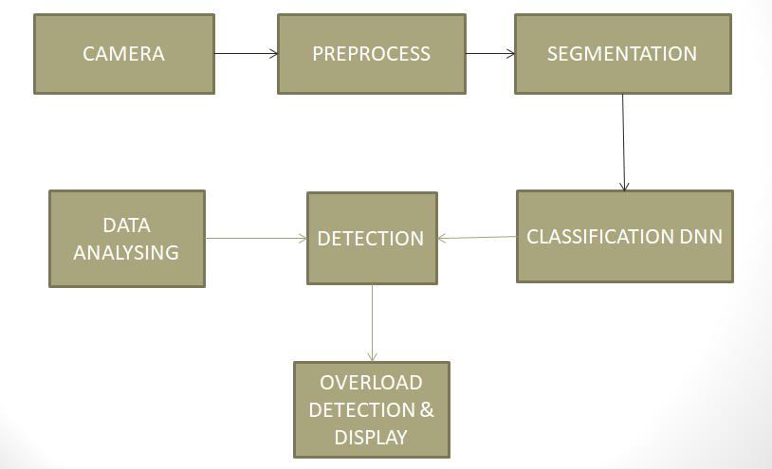

Fig 3.1 Architectural Diagram

The different modules of passenger control system are camera, pre-process, segmentation, classification DNN, detection and display, data analysing. The brief descriptions about these modules are given below:
A. Camera
Acquire image using camera. One camera at front. and other at top. Here it used for capturing the real time video of passengers. A camera is an optical instrument used to record images. At their most basic, cameras are sealed boxes (the camera body) with a small hole (the aperture) that let light in to capture an image on a light-sensitive surface.
B. Pre-process
There are few preprocessing like noise calculation, gray scale conversion, threshold and canny.

Noise Calculation: Sense to suppress the noise on pre-processing data. Noise to be avoided to reduce the complexity in experiment. Real-world data, which is the input of the system, are affected by several components among them, the presence of noise is a key factor. The presence of noise in the data may affect the intrinsic characteristics of a classification problem, since these corruptions could introduce new properties in the problem domain.

Grayscale Conversion: Conversion of color image into grayscale image. It reduces a lot of information which are not required and also will save lot of computational power as well. A grayscale image is one in which the value of each pixel is a single sample representing only an amount of light that is, it carries only intensity information. Grayscale images, a kind of black-and-white or gray monochrome, are composed exclusively of shades of gray. In this experiment no need of color image.

Threshold: Threshold image analysis technique is a type of image segmentation that isolates objects by converting grayscale images into binary images. So that the number of segments can be reduced.
Canny: The Canny edge detector is an edge detection operator that uses a multi-stage algorithm to detect a wide range of edges in images. The Canny has three adjustable parameters like the width of the Gaussian the noise and the low and high threshold for the hysteresis thresholding.

C. Segmentation

Segmentation is the process of portioning a digital images into multiple segments. The goal of segmentation is to simplify OR change the representation into something that is more meaningful and easier to analyze. Image segmentation is typically used to locate objects and boundaries (lines, curves, etc.) in images. More precisely, image segmentation is the process of assigning a label to every pixel in an image such that pixels with the same label share certain characteristics. Contouring is the important part in segmentation.
Contouring: Contours can be explained simply as a curve joining all the continuous points, having same colour or intensity. The contouring is a useful tool for shape analysis, object detection and recognition.

D. Classification DNN

Classifies the images into person, handbag and suitcase using Deep Neural Network. Train a simple neural
network to perform regression and classification. It is able to improve on performance of DNN by Adding more layers, experimenting different optimizer function/regularization function, increasing number of epochs, increasing amount of data.

E. Detection and Display

Number of passenger’s detected then average weight is detected and displayed on the screen. Here the number of passengers counted and also weight detected by analyse the luggage and then it is displayed on the screen.

F. Data Analysing

Data analysing is a process for obtaining raw data and converting it into information useful for decision making by users. Data analysis is defined as a process of cleaning transforming and modelling data to discover useful information for business decision making. An analyzer or analyzer is a personor luggage that analyses given data. It alsoexamines in detail the structure of the given data and tries to find patterns and relationships between parts of the data. An analyzer can be a piece of hardware or a computer program running on a computer.

Fig 3.2 shows the use case diagram of the proposed system in which the user can obtain the output display. Such that overload detector will be able to predict the overload.

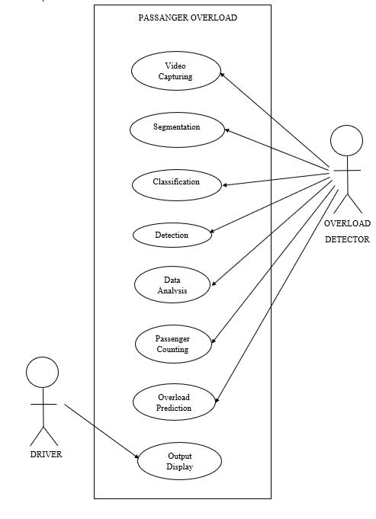

.

Fig 3.2 Use Case Diagram

The processes involved here is such as video capturing, segmentation it is the process of partitioning a digital image into multiple segments, Then it will classifies person, handbag and suitcase using deep learning technology.

IV.RESULTS
The passenger control in smart cities using deep learning solve the problem of overload in the vehicles by counting each people or bags. Using this system has achieved good results for detecting overloading in vehicles. Number of passengers collisions due to the overloaded problem is expected to be reduced using this method.
While travelling, the real time video was successfully captured by the attached camera module. Face detecting whether the face is of the human and it will divide the passengers as single blocks and then count the number of blocks. The number of blocks are equal to number of passengers it is no efficient for overload detection of the vehicle. So we are considering the luggage that is taken along with the passenger and an average weight is given for the load. Then it is combined with the number of passenger and system will predict whether the vehicle is overload or not. For detection part we got an accuracy of 90% and the classification portion showed a 97% accuracy.

V.CONCLUSION

System will provide the detection of passenger overload in taxies. Overload can be detected by using passenger detection method. In this method we consider the auto taxies as well as the public transport. We know that due to the overload in the vehicles the accidents are increasing day by day so using this method the number of accidents can be avoided or reduced. In this method the number of passengers will be counted and also it will detect the back bag, luggage and school bag. A deep learning system will be provided in the corresponding vehicle with camera. The system is introducing and a deep learning approach to find the overload in vehicle .It will give a warning if there is overload in taxies. Acquire the real time video using camera and system detect and analyze overload using deep learning mechanism using camera. So we are considering the luggage that is taken along with the passenger and an average weight is given for the load. Mainly because of using deep learning concepts we can increase the speed of the process and the efficiency .So using this method we can detect the overload in the vehicles and it can be solved very easily.

ACKNOWLEDGEMENT

We would like to express our immense gratitude and profound thanks to all those who helped us to make this project a great success. We express our gratitude to the almighty God for all the blessings endowed on us. We express our thanks to our Executive Director REV.FR. GEORGE PAREMAN, Director Dr. ELIZABETH ELIAS Principal Dr. NIXON KURUVILA for providing us with such a great opportunity. We are thankful for the help and appreciation we received from head of the department Dr. RAJESWARI M., project coordinators Ms. DEEPA DEVASSY, Ms. ANLY ANTONY and Mr. WILLSON JOSEPH. We would also extend our deep sense of gratitude to our project guide Ms. SHEETHAL M S for their guidance and advice .We would like to express our gratitude towards our parents for their timely co-operation and encouragement. Every project is successful due to the effort of many people. Our thanks and appreciations go to all our peers who had given us their valuable advice and support and pushed us into successfully completing this project.

REFERENCES

- A. S. A. Nasir, N. K. A. Gharib and H. Jaafar, "Automatic Passenger Counting System Using Image Processing Based on Skin Colour Detection Approach," 2018 International Conference on Computational Approach in Smart Systems Design and Applications (ICASSDA), Kuching, 2018, pp. 1-8, doi: 10.1109/ICASSDA.2018.8477628.

- Q. Fan, "Overload Monitoring System for Inland River Ferries," 2019 5th International Conference on Transportation Information and Safety (ICTIS), Liverpool, United Kingdom, 2019, pp. 1487-1490, doi: 10.1109/ICTIS.2019.8883679.

- Z. He, Y. Chen, L. Sun, J. Zhong and Y. Zhu, "Identifying Station-Link Correlation for Target Passenger Flow Control in Subway Network," 2018 21st International Conference on Intelligent Transportation Systems (ITSC), Maui, HI, 2018, pp. 84-89, doi: 10.1109/ITSC.2018.8569533.

[4] Z. Sheng, K. Tian, Q. Tian and H. Qu, "A Faster R-CNN Based High-Normalization Sample Calibration Method for Dense Subway Passenger Flow Detection," 2018 11th International Congress on Image and

